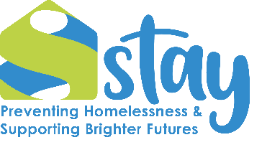
Equality and Diversity Questionnaire
Our policies and procedures are designed to ensure that all applicants receive equal treatment regardless of their gender (including gender reassignment), racial origin, disability, religion or belief, age, marital status (including civil partnerships), parental status, social status, or any other irrelevant distinction between people (the exception to this is where there is a genuine occupational qualification).
To monitor whether our policy is carried out, would you please provide the following information? This information is separated on receipt of your application. It is not seen by anyone involved in the selection process and is used solely for recruitment monitoring purposes.

1. Race / Ethnic Origin
Please tick one box
[ ] British Asian | [ ] British Black
[ ] British White | [ ] Irish
[ ] Caribbean Black | [ ] African Black
[ ] Asian | [ ] Chinese
[ ] Other European White | [ ] I prefer not to disclose
Other: Please specify ________________________

2. Gender
Please tick one box
[ ] Male [ ] Female [ ] Non-binary
[ ] Prefer to self-describe: ________________________
[ ] Prefer not to say

3. Age Range
Please tick one box
[ ] 16–18 [ ] 19–35 [ ] 36–49 [ ] 50–59 [ ] 60–65 [ ] 65+

4. Disability
Do you consider yourself to have a disability as defined by the Equality Act 2010, which states that a person is disabled if they have "a physical or mental impairment which has a substantial and long-term adverse effect on their ability to carry out normal day-to-day activities"?
[ ] Yes [ ] No [ ] Prefer not to say

5. Lived Experience
Stay is committed to understanding the diverse backgrounds of our team. Do you have personal experience of homelessness and/or sleeping rough?
[ ] Yes [ ] No [ ] Prefer not to say

6. Declaration and Consent
I agree to this data being brought forward and kept for the purpose of monitoring staff employed by Stay should my application be successful.
Signed |  | Date of Birth
Name in block capitals

PLEASE RETURN THIS FORM WITH YOUR APPLICATION

