JOB DESCRIPTION
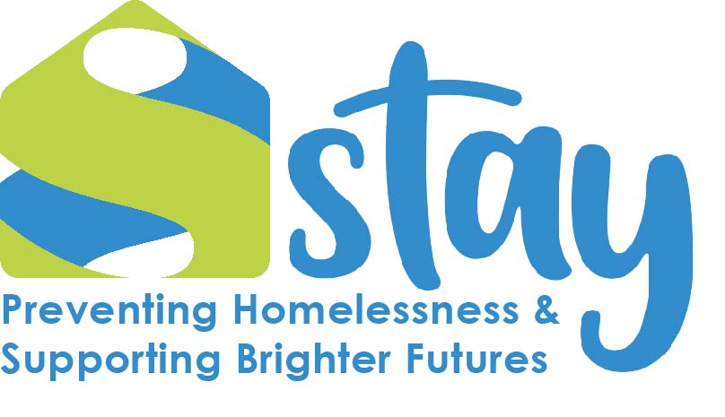

Post: Concierge Worker

Responsible to: Property Management Team Leader

Stay’s Vision: To end homelessness, and empower people to rebuild their lives

Stay’s Mission: To Prevent the causes of homelessness; to Respond to the immediate needs of those who face homelessness; to Champion the needs of homeless individuals at every opportunity.

Stay’s Values: Passionate, Integrity, Collaboration, Effective.

Information on Stay

Stay has been a specialist charitable housing provider and a provider of person-centred support for over 30 years. We support over 1000 people each year across a range of accommodation and support services. We act as a safety net and springboard for people across the Borough of Telford & Wrekin. We catch people when they need help, and support them to thrive so they can be the best they can be. With the right support, at the right time, we know people can realise their dreams and aspirations and this work can be very rewarding.

Stay works with people in crisis due to homelessness and the many effects of homelessness. All staff must have empathy with this client group who often will have multiple and/or complex needs affecting their physical, mental, social or financial wellbeing. it is essential that a person-centred approach is adopted for each client, that staff are professional and resilient enough to be able to deal effectively and constructively with a variety of challenging situations.

To be responsible for the safety and security of Stay’s accommodation, adhering to health and safety and fire safety. Working within the Voids and Maintenance team on speedy void turnaround. To contribute where appropriate, to delivering a client focused service to enable clients to develop and build upon their tenancy management skills to establish an independent lifestyle.

Role Specific Responsibilities
- To ensure accommodation is being maintained by undertaking regular Health and Safety checks.
- To ensure empty properties/ rooms are brought to a lettable standard within Stay’s lettings policy timescale.
- To work alongside the wider Housing team to ensure void targets are met in line with void loss and turnaround timescales.
- To report maintenance and health and safety issues to Property Management Team Leader.
- To take guidance and leadership from Property Management Team Leader regarding tasks.
- To perform minor maintenance tasks, including furniture assembly and door handle replacement. Duties at times may include at times decorating rooms.
- To perform cleaning duties in empty rooms and other areas of the accommodation as needed.
* Full detailed job description will be provided to the successful applicant

Staff Expectations – how we do things
Administration Duties
- Maintain accurate records, both paper and electronic.
- Assist in the production of management information related to key performance indicators.
Financial Management
- Work within departmental budgets and aim to achieve value for money in all areas.
- Ensure compliance with all financial policies and procedures.
Relationships and Partnerships
- Maintain and enhance working relationships internally with support colleagues and central services, externally with referral agencies, landlords, the Local Authority etc.
- Assure compliance with Management Agreements and Leases and report as required to partner landlords on housing management performance.
Client Involvement
- Encourage and support meaningful client involvement in all aspects of the service delivery and embed Involvement at the core of the service provision.
- To make a difference to clients through support which every day impacts on their lives for the better.
Quality Assurance
- Report on performance monthly to line manager within deadline.
- Assist in addressing any improvements required from internal or external audits.
- Ensure that Equality & Diversity is actively promoted in all areas of work and that the services are relevant and accessible to all.
- To undertake development and training opportunities and have responsibility for obtaining maximum benefit through review, reflection and practice.
- To continuously review own working practices in line with client feedback and current best practice.
- To review and evaluate own performance to identify strengths and areas for development. Identify own learning/development needs and opportunities by attending and contributing to regular support, supervision and appraisal sessions.
Culture, Values and Behaviour
- To articulate and personally demonstrate Stay’s values both internally and externally.
- Where possible work to alleviate feelings of prejudice and stigma experienced by homeless or marginalised groups.
- To contribute to the building of a staff culture where every person feels empowered and valued.
- To be professional at all times and demonstrate a great positive attitude, be empathetic and adopt a person-centred way of working.
- To commit to learning and being the best through continual learning and development.
- To show consistent integrity, trust and fairness that embraces equality, diversity and inclusion.
- To deliver time after time to a consistent standard of service in line with Stay’s policies and procedures.
- To use good judgment and initiative to find solutions.
Health and Safety
- To be aware of Stay’s policies and procedures, ensure they are carried out and that good practice is maintained.
- You have a duty to take care of your own health and safety and that of others who may be affected by your actions at work. You must co-operate with Stay and co-workers to help everyone meet their legal requirements.
The responsibilities of this post may vary from time to time without changing the general character of the post or level of responsibility entailed.

