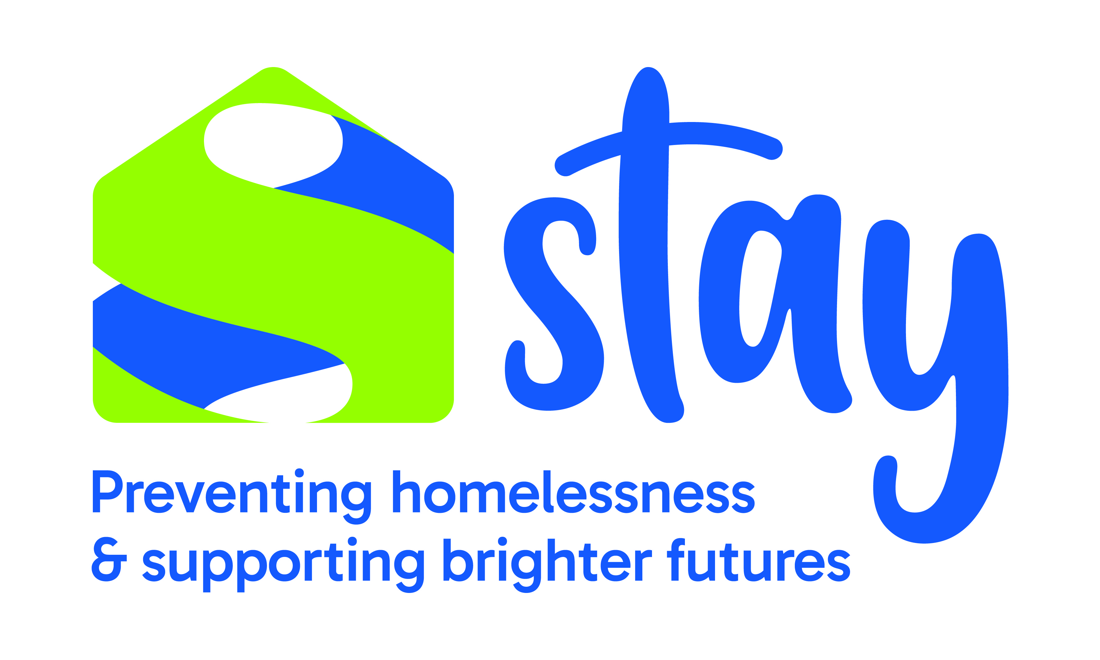
Job Description

Job Title: | Domestic Abuse Housing Team Leader
Responsible to: | Operations and Services Manager
Responsible for: | Leading a team of Housing Support Officers and the Dual Diagnosis Worker, including oversight of the domestic abuse house and the quality and consistency of housing management and support services.
Contract: | Permanent following successful completion of the probationary period
Hours: | 37 hours per week over five days
Location: | Telford & Wrekin
Salary: | £14.65 per hour
Base: | Telford

Stay’s Vision: To end homelessness, and empower people to rebuild their lives

Stay’s Mission: To Prevent the causes of homelessness; to Respond to the immediate needs of those who face homelessness; to Champion the needs of homeless individuals at every opportunity.

Stay’s Values: Passion, Integrity, Collaboration, Effective.

Stay is a local homeless charity which has been providing supported housing and services to homeless and vulnerable people for over 30 years. We support over 1,000 people each year.

We work with people in crisis due to rough sleeping, homelessness and the many effects of homelessness. We provide support in our accommodation, in the community or on the streets. We take a person-centred approach enabling people to focus on what they need to achieve in order to overcome the barriers that may have contributed to their homelessness. In our accommodation we provide intensive housing support across numerous bed spaces in Telford & Wrekin, which are a mix of HMOs and self-contained units.

We provide practical advice and support to reduce and prevent the risks of homelessness. We work with other organisations and agencies to enable our tenants and clients to have access to support and prevent rough sleeping. With the right support, at the right time, we know people can realise their dreams and aspirations which makes working at Stay very rewarding.

Job Purpose:
The purpose of this role is to manage a small team of Housing Support Officers and our in-house Dual Diagnosis Worker, providing effective leadership across housing services, including the domestic abuse house. The postholder will ensure the delivery of consistent, efficient and tenant-focused housing management services, helping residents and tenants sustain their accommodation and move towards independent and positive lifestyles.

The postholder will build effective relationships with colleagues, landlords, local authorities, referral agencies and other partners, while supporting the development of Stay’s housing strategy, policies, procedures, culture and ethos.

Key Responsibilities:

Housing Management, Leadership and Service Delivery
- Lead and line manage a small team of Housing Support Workers and the Dual Diagnosis Worker, including supervision, appraisal, training, team meetings, staff cover and performance management, in liaison with the Operations and Services Manager and HR.
- Ensure the delivery of an efficient, consistent and tenant-focused housing management service, including tenancy sustainment, rent collection, arrears, anti-social behaviour, complex cases and tenancy enforcement.
- Oversee the Domestic Abuse House as part of the wider housing service, ensuring safe, consistent and responsive day-to-day management.
- Ensure high-quality, person-centred support is delivered consistently, monitoring practice and outcomes and addressing any areas for improvement.
- Provide advice and guidance to staff on housing management, safeguarding, property, financial and wellbeing matters, ensuring risks and incidents are managed and escalated appropriately.
- Oversee fair, timely and evidenced referral, assessment, selection and allocation decisions, working alongside the Voids and Maintenance Team to minimise turnaround times and rent loss.
- Develop effective relationships with landlords, registered providers, local authorities, referral agencies and other partners, ensuring compliance with management agreements and leases.
- Monitor housing performance, maintain accurate records and provide reports to the Operations and Services Manager on arrears, voids, rent loss, resident progression, service targets and required improvements.
- Take the operational lead for safeguarding within the Housing Team, ensuring concerns are recorded, reported and managed in line with organisational procedures.
- Work with the Operations and Services Manager to review and improve housing strategy, policies, procedures and systems, maintaining current knowledge of housing practice and relevant legal and regulatory requirements.

General Responsibilities

- Contribute to the charity’s strategic objectives and operational plans.
- Maintain professional boundaries and confidentiality at all times, upholding the charity’s values and ethos.
- Maintain and enhance internal and external working relationships.
- Adhere to all GDPR requirements and organisational privacy protocols to safeguard the personal data of customers, clients/tenants, and colleagues.
- Be aware of Stay’s policies and procedures, ensure they are followed and that good practice is maintained.
- Proactively uphold safeguarding policies and procedures to ensure the safety and wellbeing of vulnerable adults and children, identifying potential risks and following established reporting procedures.
- Participate in team meetings, training, supervision and appraisals as required.
- Ensure that you take care of your own Health and Safety and that of others who may be affected by your actions.
- Ensure that Equality, Diversity and Inclusion is actively promoted in all areas of work and that the services are relevant and accessible to all.
- Undertake any other duties as reasonably required.

Person Specification
Role: Domestic Abuse Housing Team Leader
Criteria | Essential Criteria | Desirable Criteria
1. Qualifications & Training | - Relevant housing, management or leadership qualification, or equivalent demonstrable experience.  - Commitment to continuing professional development and required organisational training. | - Level 3 or above qualification in Housing, Leadership and Management, or a related discipline.
2. Experience | - Experience of intensive housing management, supported accommodation, domestic abuse accommodation, homelessness or a related service.  - Experience of supervising or line managing staff, including support, performance management and development.  - Experience of managing rent arrears, voids, anti-social behaviour, complex cases and tenancy enforcement.  - Experience of working with people with multiple and complex needs, including mental health and substance use needs.  - Experience of monitoring performance, producing reports and contributing to audits or service improvement. | - Experience of working with landlords, registered providers, local authorities and multi-agency partners.  - Experience of management agreements, leases or exempt accommodation.
3. Knowledge | - Strong knowledge of housing management practice.  - Understanding of safeguarding, equality and diversity, health and safety, data protection and confidentiality. | - Knowledge of local services and partnership networks in Telford & Wrekin.  - Understanding of the needs and barriers experienced by people who are homeless, vulnerable or have multiple and complex needs
4. Skills and abilities | - Strong leadership, staff management, coaching and decision-making skills.  - Clear written and verbal communication, with the ability to manage difficult conversations and complaints professionally.  - Ability to prioritise workloads, manage risk and use IT systems and performance information to maintain records, make decisions and produce reports.
5. Personal attributes | - Professional, resilient, approachable and able to remain constructive in challenging situations.  - Committed to person-centred, fair and consistent services and to Stay’s vision, mission and values.  - Uses sound judgement, initiative and accountability while working collaboratively.
6. Additional requirements | - Willingness to undertake an Enhanced DBS check.  - Ability to work flexibly across Stay sites and participate in the on-call rota as required.  - Full UK driving licence and access to a vehicle for work, with the ability to travel across Telford & Wrekin as required.

This job description is intended as a guide to the main responsibilities of the role and may be reviewed in line with service developments.

